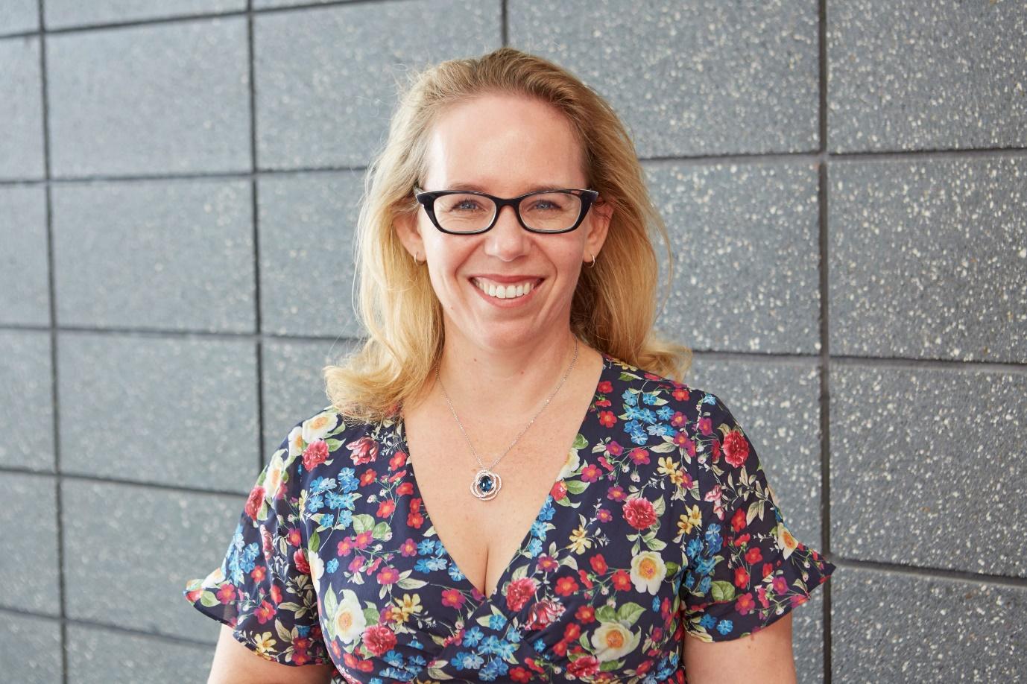

**Rachael Hayton - Artist**

As an Artist it has only been since I made the step to be self-employed that I realised I could also make time for my Art. It has always been a passion but time often is a struggle when there are so many competing priorities in life. Taking the time to attend WSA classes and exploring my own style has been fulfilling. I’m all about the colour and the way that no matter how many photos you take you can’t capture your unique experience or really explore your imagination. Painting to me is away to show the world how you see it.

