Realistic Pet Portraits in Watercolour – Class requirements

PHOTO/PHOTOS:
In order to participate we need you to provide a good quality photo of the pet you wish to paint.
It needs to be:
- A well-lit photo
- Closely cropped to your pet, with minimal background.
It needs to be printed:
- In A4 size, plain paper is fine.
- One copy in full colour and the exact photo printed again in greyscale (black and white)
- Cropped closely to your pet.

We cannot paint from an image on a cell phone, they must be printed once in colour and once in black and white. Please feel free to bring multiple photos/printouts and we can pick on the day.

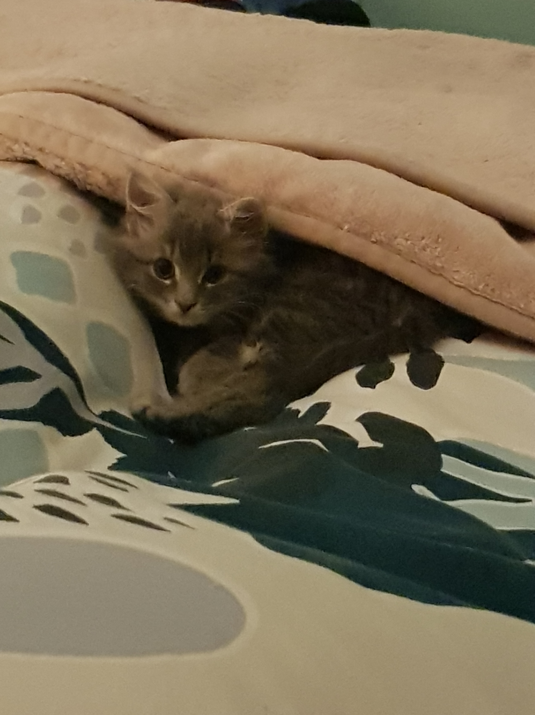  × poor lighting and too far away | 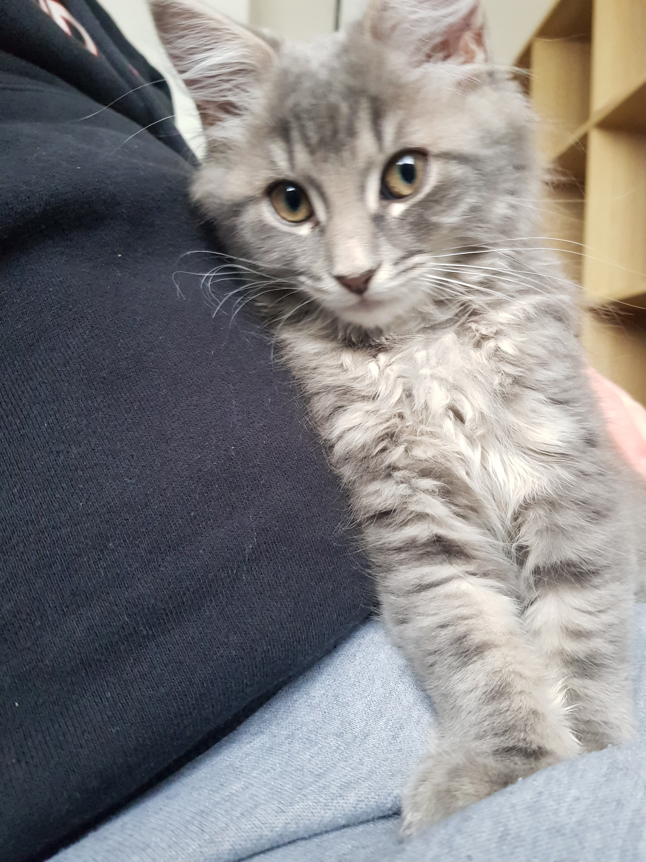× good lighting but too fuzzy, too much background and not enough of the pet can be seen. | 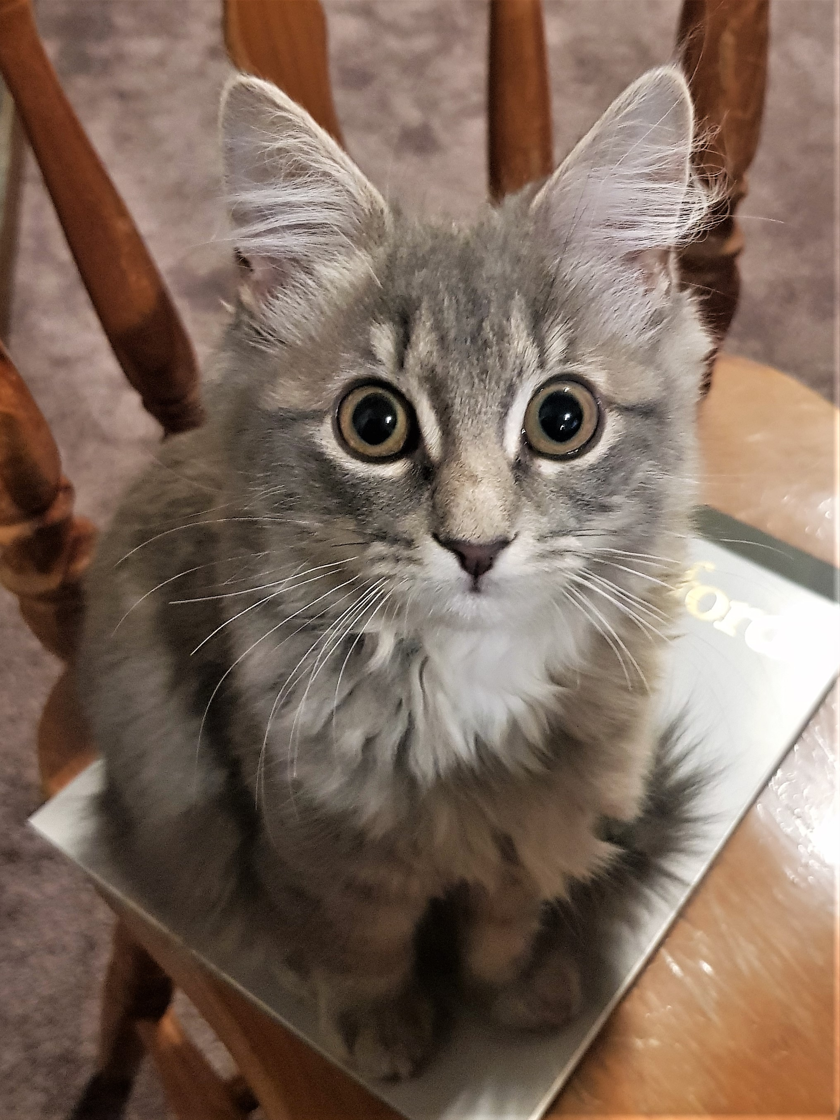  ♥ closely cropped. Fuzzy detail in the body, enough detail and interest in the face.

If you cannot provide printed photos, please contact the WSA office prior to class starting at wsa@wsa.org.nz for assistance. ***We will not be able to print photos on the day.

